

**B.M.S. COLLEGE OF ENGINEERING**

**(Autonomous Institute, Affiliated to VTU)**

**Bull Temple Road, Basavanagudi, Bengaluru - 560019**



A Capstone Project Report on

***“PROJECT TITLE”***

Submitted in partial fulfilment of the requirements for the award of degree

**BACHELOR OF ENGINEERING**

**IN**

**INFORMATION SCIENCE AND ENGINEERING**

By

STUDENTS NAME WITH USN

**Under the guidance of**

**Dr./ Prof. GUIDE NAME**

DESIGNATION

**Department of Information Science and Engineering**

**2021-2022**

***Crop Yield Prediction based on Indian Agriculture using  
Machine Learning and Computer Vision”***

By

**Keshav Singh**

**BACHELOR OF ENGINEERING**

**IN**

**INFORMATION SCIENCE AND ENGINEERING**

**TABLE OF CONTENTS**

|  |  |  |  |  |
| --- | --- | --- | --- | --- |
| **Acknowledgement** | | | | **i** |
| **Abstract** | | | | **ii** |
| **Table of Contents** | | | | **iii** |
| **1** | **INTRODUCTION** | | | **1** |
|  | 1.1 | Overview | | 1 |
| 1.2 | Motivation | | 5 |
| 1.3 | Objective | | 5 |
| 1.4 | Scope | | 6 |
| 1.5 | Existing System | | 7 |
| 1.6 | Proposed System | | 9 |
| **2** | **PROBLEM STATEMENT** | | | **11** |
|  | 2.1 | Problem Statement | | 11 |
| 2.2 | Motivation | | 11 |
| 2.3 | Objectives | | 12 |
| **3** | **DETAILED SURVEY** | | | **13** |
| **4** | **SURVEY SUMMARY TABLE** | | | **28** |
| **5** | **SYSTEM REQUIREMENT SPECIFICATION** | | | **31** |
|  | 5.1 | Functional Requirements | | 31 |
| 5.2 | Non-functional Requirements | | 31 |
| 5.3 | Hardware Requirements | | 32 |
| 5.4 | Software Requirements | | 33 |
| **6** | **SYSTEM DESIGN** | | | **34** |
|  | **6.1** | **System Design** | | 34 |
|  | 6.1.1 | System Architecture | 34 |
| 6.1.2 | Module Design | 35 |
| **6.2** | **Detailed Design** | | **36** |
|  | 6.2.1 | Class Diagram | 36 |
| 6.2.2 | Activity Diagram | 37 |
| 6.2.3 | Use Case Diagram | 38 |
| 6.2.4 | Scenarios | 39 |
| **7** | **IMPLEMENTATION** | | | **41** |
| **8** | **RESULTS (SNAPSHOTS)** | | | **48** |
| **9** | **TESTING** | | | **60** |
|  | **CONCLUSION AND FUTURE ENHANCEMENTS** | | | **70** |
| **BIBLIOGRAPHY** | | | **71** |
| **APPENDIX A: LIST OF FIGURES** | | | **72** |
| **APPENDIX B: LIST OF TABLES** | | | **73** |

**LIST OF FIGURES**

|  |  |  |
| --- | --- | --- |
| **1.1** | **Figure Label** | **2** |
| **1.2** | **Figure Label** | **4** |
| **5.1** | **Figure Label** | **20** |
| **5.2** | **Figure Label** | **22** |
| **5.3** | **Figure Label** | **23** |
| **6.1** | **Figure Label** | **25** |
| **6.2** | **Figure Label** | **28** |
| **6.3** | **Figure Label** | **30** |

**CHAPTER 1**

**INTRODUCTION**

* 1. **Overview**

The backbone of the Indian economy is Agriculture. As we all know, food is essential for survival; agriculture and environmental sectors need to be given the highest preference for development. Indian agriculture sector accounts for almost 18% of Indian agriculture GDP and provides employment to 50%-60% of the country’s workforce.

The main reason for considering the Agriculture sector is because it plays a crucial role in developing and maintaining the country’s economy. The proposed system will use the Crop Selection as the area of research since it is the first and most important milestone in the process of agricultural development and the success of this milestone guarantees the result of production.

Agriculture development and enhancement aids the crop producers with the help of many agricultural resources. As a result, it provides high efficiency, high productivity with low consumption of resources.

* 1. **Motivation**

India has a vast economy based on agriculture whose most of the GDP comes from farming. The motivation of this project comes from the increasing suicide rates in farmers which may be due to low harvest in crops.

Climate and other changes related to the environment have become a significant threat in the agriculture field. Machine learning is an important and essential approach for achieving practical and suitable solutions for this problem.

Predicting yield of the crops from historical available data like weather, rainfall, soil parameters and historic crop yield. We will achieve this using the machine learning algorithm. We will do a comparative study of various machine learning algorithms.

In this project a web application will be developed which predicts the crop yield in general and for a particular crop. Along with that, it will also suggest to the user if it is the right time to use the fertilizer or not.

**1.3 Objective**

**This project aims at predicting the crop yield at any particular condition and thereby recommending suitable crops for that field. It involves the following steps :**

* Collect the weather, crop yield, soil type and the rainfall data and merge these datasets in a structured form and clean the data. Data Cleaning is done to remove inaccurate, incomplete and unreasonable data that increases the quality of the data and hence the overall productivity.
* Perform the necessary analysis that helps in analysing the complete dataset and summarize the main characteristics. Discover patterns, spot anomalies and graphical representations of various attributes (Data Cleaning).
* Divide the analysed data into training and testing sets and train the model using the training data to predict the crop yield for given inputs.
* Compare various Algorithms by passing the analysed dataset through them and calculating the error rate, accuracy for each. Choose the algorithm with the highest accuracy and lowest error rate.
* Implement a system in the form of a Web Application and integrate the algorithm at the back end.
  1. **Scope**

The application can practically be used by any individual by any third party managing the dataset.

The proposed system also ensures security of the data it stores, and provides the client with the assurance that its private and confidential data cannot be viewed by any unauthorized person(s).

The data obtained is stored in cloud(AWS), hence extra security is provided to the confidentiality of the data.

Security groups are configured in the cloud console to provide restricted access to the contents of the cloud.

The proposed system provides analysis for the farmers by predicted crops and prices based on the inputs provided.

* 1. **Existing System**

Nowadays, dilettante farmers find it hard to understand the cultivation process, crop type, climate change, etc. Farming is the spine for every country's economy. Future agriculture depends on dilettante farmers.

But new farmers are not so strong at farming, So Machine learning helps to solve their problems. The system which already exists predicts the crop yield by using the parameters of the soil and recommends Fertilizer using machine learning. It uses the information of crop yield to make the users decide on the crop to be sown. Hence the system is not simple enough for the farmers to understand.

**1.6 Proposed System**

The following constraints are considered for the proposed system :

* Reducing the number of resources required and utilising them more efficiently.
* Using AWS and its features to securely and efficiently store the dataset and visualize the output.
* Comparing the various models to find out the perfect model.
* Utilising the features of **Cloud Computing**(AWS) in addition to the existing approaches.

**CHAPTER-2**

**PROBLEM STATEMENT**

**2.1 Problem Statement**

Predict the crop yield and deliver the end user with proper recommendations about required fertilizer ratio based on soil parameters. We also recommend the crop price using machine learning.

**2.2 Motivation**

* India has a vast economy based on agriculture whose most of the GDP comes from farming. The motivation of this project comes from the increasing suicide rates in farmers which may be due to low harvest in crops.
* Climate and other changes related to the environment have become a significant threat in the agriculture field. Machine learning is an important and essential approach for achieving practical and suitable solutions for this problem.
* Predicting yield of the crops from historical available data like weather, rainfall, soil parameters and historic crop yield. We will achieve this using the machine learning algorithm. We will do a comparative study of various machine learning algorithms.
* In this project a web application will be developed which predicts the crop yield in general and also for a particular crop. Along with that, it will also suggest to the user if it is the right time to use the fertilizer or not.

**2.3 Objectives**

* Implement the existing machine learning algorithms and compare the results.
* Arrive at the most efficient algorithms by comparing the features of each of the algorithms.
* In order to safely store the data and provide confidentiality, a secured storage mechanism is also required.
* Develop a model that takes care of the challenges faced by the current algorithms/approaches.
* Use other domains of Computer Science to increase performance of analysis, if required.
* The datasets are stored in an **AWS S3 bucket**.
* **AWS Lambda** is used for automation.
* An **AWS EC2** instance is used to deploy the trained ML model, on the global platform, as well as provides the required processing power for the ML model.
* **AWS ECR** contains an image of the trained ML model, to be used in case of loss, breakdown, repair of the aforementioned EC2 instance.
* **Flask** has been used to deploy the Python-developed application.
* The UI where the user enters the symptoms has been made user friendly and interactive by using **HTML, Javascript,** and **CSS**.
* **PuTTy** and **WinSCP** have been used to connect the local machine where the entire application was developed to the EC2 instance, and deploy the application on a global address.
* **Cron** expression to automate the process
* Building **layers** for Lambda

**CHAPTER-3**

**DETAILED SURVEY**

**Paper 1: [2019] Crop Yield Prediction using Machine Learning Algorithms [Gopal PM, Bhargavi R]**

This paper predicts the crop yield by using various ML algorithms. The models used here include LR, NB, and Random Forest. Random Forest provides maximum stability, and accuracy. The prediction made will help the farmers to decide as to which crop to grow to induce the most yield by taking factors like temperature, rainfall etc. into consideration. This bridges the gap between technology and agriculture sector.

**Paper 2: [2018] Crop Yield Prediction by using Machine Learning Techniques [Gonzalez-Sanchez, Frausto-Solis]**

The growth of the national economy depends on Agriculture. ML is important for gaining real world solutions and operative solutions for the crop yield problems. Agriculture is dependent of factors such as soil, climate, precipitation etc. because of this, the crop yield is difficult to predict. In this paper, they have performed descriptive study on agricultural data using ML techniques. Here the authors have utilized three datasets. They are divided into training set and testing set. K-Nearest Neighbor (KNN) is applied on them. The model exhibits the expense of assessed crop yield, and they are marked as Low, Mid and High.

**Paper 3: [2015] Machine Learning: Algorithms, Real-World Applications and Research Directions [Choudhary, Jones J]**

In the 4G Era, the digital world has a vast wealth of data like, IoT data, cybersecurity data, mobile data etc. To analyze the above-mentioned data, AI, and ML are the key concepts. In this paper, the authors have presented a comprehensive study on the ML algorithms that will be applied to increase the intelligence and the capabilities of an application. This paper serves as a notice for both academic and industry professionals, and for decision makers in different real-world situations and other areas, particularly from the technical viewpoint.

**Paper 4: [2019] Crop yield prediction using machine learning: A systematic literature review [Medar, Ramesh A]**

ML is a significant tool for crop yield prediction. Several ML algorithms are applied to support many crop yield predictions. In this paper, we have performed SLR to synthesize the algorithms and features. An additional search on electronic databases has been performed to identify deep learning. According to this analytical search, CNN is the most widely used DL algorithms and the others are LSTM, and DNN.

**Paper 5: [2017] An interaction regression model for crop yield prediction [Vijay R, Yogesh]**

In this paper, the authors have introduced a new prediction model based on regression. The main contribution of this model is its capability to form accurate predictions and accurate insights simultaneously. This is achieved by training and testing features and interactions that are temporarily and spatially robust to balance accuracy for the training data and the test data.

**Paper 6: [2016] Crop yield prediction integrating genotype and weather variables using deep learning [Gandhi N, Petkar]**

In this paper, the authors have used performance records from UST in America to build LSTM – Recurrent Neural Network based prediction model which predicts genotype response in a particular environment. The proposed model uses SVM with SVR-RBF, and LASSO for yield prediction. Also, for providing time-windows in the growing season, they have developed an attention mechanism for LSTM models. The outputs of such models will provide useful insights to plant breeders.

**Paper 7: [2018] A CNN-RNN Framework for Crop Yield Prediction [Nigam A, Garg S, Agarwal A]**

Predicting crop yield is an extremely challenging affair because of its dependance on factors such as crop genotype, environment, and other interactions. In this paper, the authors have presented a deep learning module using CNNs and RNNs for crop yield prediction. The proposed model, along with other methods such as RF, DFNN, and LASSO, was used to forecast soybean and corn yield. The new model achieved a RMSE of 9%, substantially outperforming all other models.

**Paper 8: [2017] A Survey on Plant Disease Prediction using Machine Learning and Deep Learning Techniques [Oettli Pascal, Benjamin Sultan]**

The major products of agriculture in India are wheat, rice, spices, and pulses. As the population is increasing rapidly, the demand for such products are also increasing alarmingly. Protecting the crops play an important role in maintaining agricultural products. Pathogen, pest, and animals are responsible for the loss in productivity. ML techniques like RF, BN, DT, and SVM, help in the automatic detection of plant disease by considering visual symptoms in the plant. A survey of various such techniques are presented in this paper.

**Paper 9: [2019] Deep Gaussian Process for Crop Yield Prediction Based on Remote Sensing Data [Christian Baron, Mathieu Vrac]**

Agricultural monitoring can help prevent famine and aide in humanitarian efforts. The main challenge is yield estimation. In this paper, the authors have introduced an accurate, scalable, and inexpensive method for crop yield prediction using remote sensing data. This approach, according to the authors, improves existing systems in three ways. First, they will remove old features traditionally and introduce an approach based on modern learning ideas. They also propose a CNN or LSTMN and automatically learn features that are useful when training data which are labeled are scarce. Finally, they incorporate a Gaussian approach to model the temporal structure of the data and improve accuracy.

**Paper 10: [2019] Multimodal performers for genomic selection and crop yield prediction [Gandhi N, Armstrong LJ, Petkar O]**

In this paper, the authors have introduced a DL framework for crop yield prediction using polymorphisms and weather data. They compared the proposed models with the Bayesian methods and neural network architectures with the task of predicting soya yields across different locations. The authors have showed that the performance-based models outperform the traditional methods. Furthermore, the authors show that visualization of self-attention maps indicates that the proposed model makes meaningful connections b/w genotype and weather data.

**Paper 11: [2019] Multiple Instance Choquet Integral Classifier Fusion and Regression for Remote Sensing Applications [Dahikar V, Snehal S]**

In regression fusion, the aim of the model us the combine all the outputs of different algorithms to boost overall performance. Standard supervised algorithms require accurate training labels. This paper introduces novel classification and fusion models that could be trained following a multiple instance framework. The experiments were conducted based on the algorithms that were proposed on both applications and synthetic data and crop yield prediction using remote sensing data.

**Paper 12: [2016] Crop yield prediction using machine learning [Panda SS, Ames DP]**

Due to the impact of climate change, most of the crops are badly affected in terms of their productivity over a period. Predicting the yield of a crop in advance will help the lawmakers and farmers to take rightful measures for marketing and storage. This project will help these people to know the crop yield before cultivating and thus help them to take the right decisions. It attempts to solve the problem by introducing a prototype of an interactive prediction model. The results of this system will be made available to the farmers.

**Paper 13: [2019] Crop yield forecasting using data mining [Panigrahi S, Nevavuori]**

India is an agriculture-based economy. Economic, seasonal, and organic factors all influence crop yield. Agricultural production estimation is a difficult process for our country. Crop production assumptions will help farmers to make the necessary planning for shortcomings like storing and marketing. Data mining is the method of gathering unseen anticipated knowledge from vast database. It assists in the analysis of patterns and characters, allowing companies to make informed decisions. This research gives a fast inspection of crop yield using RF approach.

**Paper 14: [2020] An efficient algorithm for predicting crop using historical data and pattern matching technique [Nathaniel Narra, Tarmo Lipping]**

Since agriculture is an important part in food security and economic development, selecting the right crops for cultivation is an important aspect in the agricultural planning. The proposed system helps the farmers to select the right crops based on region of sowing and season. It will help the farmers to improve their net profit. By considering various datasets, the model builds a system using which it will suggest a list of crops to be grown in a particular field.

**Paper 15: [2014] Crop yield prediction from multi-spectral, multi-temporal remotely sensed imagery using recurrent 3D convolutional neural networks [Jiaxuan Yu, Xiacheng Li, David Lobell]**

In this paper, the authors have proposed a deep learning model for predicting crop yield, namely, SSTNN, which combines convolutional and RNNs to exploit their weakness. The novel spectral feature first exploits sufficient spectral features from the multi-spectral images. Finally, SSTNN is validated on wheat and other predictions from China. The results are compared using ML methods as well as DL methods. The introduced method can offer better prediction performance than other competitive methods.

**Paper 16: [2019] Cotton yield estimation model based on machine learning using time series UAV remote sensing data [Stefano Ermon, Xiao Xian]**

Predicting crop yield is of great significance for farmers to make changes, such as decisions on storage demand, crop insurance, cash flow budget, and other factors. This paper established a yield estimation model based on UAV remote sensing data. This paper provides a method which can meet the requirements of large-scale and small-scale forecasting of cotton yields and provides an idea for cotton yield measurement and breeding screening.

**Paper 17: [2019] Crop Yield Prediction using Machine Learning [Van Klompenburg, Thomas Kassanhun]**

This project proposes to help farmers with yield prediction before cultivating the crops. ML is an important approach for achieving for practical solutions for this problem. The project proposes to help the farmers by checking the soil quality based on data mining approach. It is the process of analysing data from various perspective and summarizing into information that will be useful. Thus, the system predicts the quality of the soil and improve the crop yield for better cultivation using suitable fertilizers.

**Paper 18: [2013] Crop Prediction Using Machine Learning [Cagatay Catal, Chlingaryan A]**

Agriculture is the most essential and practiced occupations in India, and it has an important role in the development of our country. In the papers, the authors have proposed a project which would solve the major agricultural problems by monitoring the area based on soil quality and recommending the appropriate crops, thereby helping the farmers to increase their productivity and avoid loss. The project is a recommendation system which uses different ML techniques to recommend the suitable crops based on the input provided by the user. This model thus reduces the loss incurred by the farmers and will also help the farmers to find different types of crops that can cultivated in a particular area.

**Paper 19: [2018] Crop yield prediction based on ensemble model using historical data [Sukkarieh S, Whelan B]**

Agriculture and its related industries are a major source of living for the people of India. Indian agriculture is in a poor condition as compared to the previous years. The main reason for this is without an organized pattern and proper instructions to the farmers. It is an important source of economy for the country. In this project, the authors introduce a recommendation system for the farmers using ML techniques. In the proposed model, they use ensemble-based hybrid system to make a strong classifier. The dataset is obtained from ML platforms for data processing. Clustering of data is performed using GMM clustering and KNN, XGBboost for data classification to define the solutions and conditions.

**Paper 20: [2019] Machine learning model for predicting crop yield production [Brett Whelan, Anna Dickinson]**

Data Mining is the greatest conceivable strategy for the predominant virtual global for perusing mass of records units to acquire left out relationship. The methodology utilized for the assessment of factual records over a time is the time assortment assessment. This technique is clinical and reliable in determining events to see over a period. Likelihood of assembling ought to ceaselessly be relied upon to the near flawlessness with the guide of utilizing time assortment assessment. In this work, suppers fabricating is the pushed for forecast. The recognized sort systems on this investigate are the Linear Regression (LR) and Naive Bayes. In this venture, Linear Regression and Naive are the proposed outfit rendition used to task the yield producing over a time span. This troupe rendition is when contrasted with Linear Regression and Naive Bayes methodologies. The boundaries utilized each in turn for expectation of yield are the precision and the sort mistake. The finding yields that Linear Regression and Naive are pleasing than Linear Regression and Naive Bayes for the records set examined

**CHAPTER-4**

**SURVEY SUMMARY TABLE**

|  |  |  |  |  |
| --- | --- | --- | --- | --- |
| SL.NO | Title of the Paper | Problem Addressed | Authors Approach / Method | Results |
| **1** | **Crop Yield Prediction using Machine Learning Algorithms** | This paper predicts the crop yield by using various ML algorithms. The models used here include LR, NB, and Random Forest. Random Forest provides maximum stability, and accuracy. | The prediction made will help the farmers to make a decision as to which crop to grow to induce the most yield by taking factors like temperature, rainfall etc. into consideration. | This bridges the gap between technology and agriculture sector. |
| **2** | **Crop Yield Prediction by using Machine Learning Techniques** | The growth of the national economy depends on Agriculture. ML is important for gaining real world solutions and operative solutions for the crop yield problems. | Agriculture is dependent of factors such as soil, climate, precipitation etc. because of this, the crop yield is difficult to predict. In this paper, they have performed descriptive study on agricultural data using ML techniques. | Here the authors have utilized three datasets. They are divided into training set and testing set. K-Nearest Neighbor (KNN) is applied on them. The model exhibits the expense of assessed crop yield and they are marked as Low, Mid and High. |
| **3** | **Machine Learning: Algorithms, Real-World Applications and Research Directions** | In the 4G Era, the digital world has a vast wealth of data like, IoT data, cybersecurity data, mobile data etc. To analyze the above mentioned data, AI, and ML are the key concepts. | This paper serves as a notice for both academic and industry professionals, and also for decision makers in different real-world situations and other areas, particularly from the technical viewpoint. | Study on the ML algorithms that will be applied to increase the intelligence and the capabilities of an application. |
| **4** | **Reference 4 :- Crop yield prediction using machine learning: A systematic literature review** | ML is a significant tool for crop yield prediction. Several ML algorithms are applied to support many crop yield predictions. | In this paper, we have performed SLR to synthesize the algorithms and features. An additional search on electronic databases has been performed to identify deep learning. | According to this analytical search, CNN is the most widely used DL algorithms and the others are LSTM, and DNN. |
| **5** | **An interaction regression model for crop yield prediction** | In this paper, the authors have introduced a new prediction model based on regression. The main contribution of this model is its capability to form accurate predictions and accurate insights simultaneously. | This is achieved by training and testing features and interactions that are temporarily and spatially robust to balance accuracy for the training data and the test data. | The main contribution of this model is its capability to form accurate predictions and accurate insights simultaneously. |
| **6** | **Crop yield prediction integrating genotype and weather variables using deep learning** | In this paper, the authors have used performance LSTM – Recurrent Neural Network based prediction model which predicts genotype response in a particular environment. | The proposed model uses SVM with SVR-RBF, providing time-windows in the growing season, they have developed an attention mechanism for LSTM models. | The outputs of such models will provide useful insights to plant breeders. |
| **7** | **A CNN-RNN Framework for Crop Yield Prediction** | Predicting crop yield is an extremely challenging affair because of its dependance on factors such as crop genotype, environment, and other interactions. | In this paper, the authors have presented a deep learning module using CNNs and RNNs for crop yield prediction. | The proposed model, along with other methods such as RF, DFNN, and LASSO, was used to forecast soybean and corn yield. The new model achieved a RMSE of 9%, substantially outperforming all other models. |
| 8 | **A Survey on Plant Disease Prediction using Machine Learning and Deep Learning Techniques** | The major products of agriculture in India are wheat, rice, spices, and pulses. As the population is increasing rapidly, the demand for such products are also increasing alarmingly. | The major products of agriculture in India are wheat, rice, spices, and pulses. As the population is increasing rapidly, the demand for such products are also increasing alarmingly. | As the population is increasing rapidly, the demand for such products are also increasing alarmingly. ML techniques like RF, BN, DT, and SVM, help in the automatic detection of plant disease by considering visual symptoms in the plant. A survey of various such techniques are presented in this paper. |
| **9** | **Deep Gaussian Process for Crop Yield Prediction Based on Remote Sensing Data** | Agricultural monitoring can help prevent famine and aide in humanitarian efforts. The main challenge is yield estimation. | In this paper, the authors have introduced an accurate, scalable, and inexpensive method for crop yield prediction using remote sensing data. | This approach, according to the authors, improves existing systems in three ways. First, they will remove old features traditionally and introduce an approach based on modern learning ideas. |
| **10** | **Multimodal performers for genomic selection and crop yield prediction** | In this paper, the authors have introduced a DL framework for crop yield prediction using polymorphisms and weather data. | The authors have showed that the performance-based models outperform the traditional methods. Furthermore In this paper, the authors have introduced a DL framework for crop yield prediction using polymorphisms and weather data. | the authors show that visualization of self-attention maps indicates that the proposed model makes meaningful connections b/w genotype and weather data. |
| **11** | **Multiple Instance Choquet Integral Classifier Fusion and Regression for Remote Sensing Applications** | This paper introduces novel classification and fusion models that could be trained following a multiple instance framework. | The experiments were conducted based on the algorithms that were proposed on both applications and synthetic data and crop yield prediction using remote sensing data. | In regression fusion, the aim of the model us the combine all the outputs of different algorithms to boost overall performance. Standard supervised algorithms require accurate training labels. |
| **12** | **Crop yield prediction using machine learning** | Due to the impact of climate change, most of the crops are badly affected in terms of their productivity over a period of time. Predicting the yield of a crop in advance will help the lawmakers and farmers to take rightful measures for marketing and storage. | This project will help these people to know the crop yield before cultivating and thus help them to take the right decisions. | It attempts to solve the problem by introducing a prototype of an interactive prediction model. The results of this system will be made available to the farmers. |
| **13** | **Crop yield forecasting using data mining** | India is an agriculture-based economy. Economic, seasonal, and organic factors all influence crop yield. Agricultural production estimation is a difficult process for our country. | Crop production assumptions will help farmers to make the necessary planning for shortcomings like storing and marketing. Data mining is the method of gathering unseen anticipated knowledge from vast database. | It assists in the analysis of patterns and characters, allowing companies to make informed decisions. This research gives a fast inspection of crop yield using RF approach. |
| **14** | **An efficient algorithm for predicting crop using historical data and pattern matching technique** | Since agriculture is an important part in food security and economic development, selecting the right crops for cultivation is an important aspect in the agricultural planning. | The proposed system helps the farmers to select the right crops based on region of sowing and season. | By considering various datasets, the model builds a system using which it will suggest a list of crops to be grown in a particular field. |
| **15** | **Crop yield prediction from multi-spectral, multi-temporal remotely sensed imagery using recurrent 3D convolutional neural networks** | In this paper, the authors have proposed a deep learning model for predicting crop yield, namely, SSTNN, which combines convolutional and RNNs to exploit their weakness. | The novel spectral feature first exploits sufficient spectral features from the multi-spectral images. Finally, SSTNN is validated on wheat and other predictions from China. | The results are compared using ML methods as well as DL methods. The introduced method can offer better prediction performance than other competitive methods. |
| **16** | **Cotton yield estimation model based on machine learning using time series UAV remote sensing data** | Predicting crop yield is of great significance for farmers to make changes, such as decisions on storage demand, crop insurance, cash flow budget, and other factors. | This paper established a yield estimation model based on UAV remote sensing data. | This paper provides a method which can meet the requirements of large-scale and small-scale forecasting of cotton yields and provides an idea for cotton yield measurement and breeding screening. |
| **17** | **Crop Yield Prediction using Machine Learning** | This project proposes to help farmers with yield prediction before cultivating the crops. ML is an important approach for achieving for practical solutions for this problem. | The project proposes to help the farmers by checking the soil quality based on data mining approach. It is the process of analyzing data from various perspective and summarizing into information that will be useful. | Thus the system predicts the quality of the soil and improve the crop yield for better cultivation using suitable fertilizers. |
| **18** | **Crop Prediction Using Machine Learning** | Agriculture is the most essential and practiced occupations in India, and it has an important role in the development of our country. | In the papers, the authors have proposed a project which would solve the major agricultural problems by monitoring the area based on soil quality and recommending the appropriate crops, thereby helping the farmers to increase their productivity and avoid loss. | The project is a recommendation system which uses different ML techniques to recommend the suitable crops based on the input provided by the user. This model thus reduces the loss incurred by the farmers and will also help the farmers to find different types of crops that can cultivated in a particular area. |
| **19** | **Crop yield prediction based on ensemble model using historical data** | Agriculture and its related industries are a major source of living for the people of India. Indian agriculture is in a poor condition as compared to the previous years. | The main reason for this is without an organized pattern and proper instructions to the farmers. It is an important source of economy for the country. | In this project, the authors introduce a recommendation system for the farmers using ML techniques. In the proposed model, they use ensemble-based hybrid system to make a strong classifier. The dataset is obtained from ML platforms for data processing. Clustering of data is performed using GMM clustering and KNN, XGBboost for data classification to define the solutions and conditions. |
| **20** | **Machine learning model for predicting crop yield production** | Data Mining is the greatest conceivable strategy for the predominant virtual global for perusing mass of records units to acquire left out relationship. | The methodology utilized for the assessment of factual records over a time period is the time assortment assessment. This technique is clinical and reliable in determining events. | The finding yields that Linear Regression and Naive are pleasing than Linear Regression and Naive Bayes for the records set examined |

**CHAPTER-5**

**SYSTEM REQUIREMENT SPECIFICATION**

**5.1 Functional Requirements**

* The system proposes to help farmers determine the soil quality by performing analysis on its different parameters and to predict crops based on the results obtained.
* The work uses the Classification algorithm of Random Forest to improve the efficiency of the system.
* The work maps the soil and crop data to predict suitable crops for the soil and it will also provide the information about various parameters like nutrients which are deficient in soil for particular crops.
* It lets the user decide on the crop to be sown. Thus, the system helps to provide knowledge to the farmers.

**5.2 Non-functional Requirements**

* It is an application which is efficient, cost effective, portable, and reliable.
* It is efficient, and the energy consumption is very low.
* It produces accurate results and is very durable.
* The Interface is portable, which means that it can be carried anywhere without much difficulty.
* The results are accurate. So, the system is highly reliable.
* The components/tools used to build the application are very cheap, and hence, cost effective.

**5.3 Hardware Requirements**

Hard Disk        :    450GB and Above

RAM                :     5GB and Above

Processor       :    I2 and Above

**5.4 Software Requirements**

Operating System : Windows 7 , 8, 10 (64 bit)

Software : Python, Java and Anaconda

Framework : Flask, HTML

**CHAPTER-6**

**SYSTEM DESIGN**

**6.1 System Design**

**6.1.1 System Architecture**

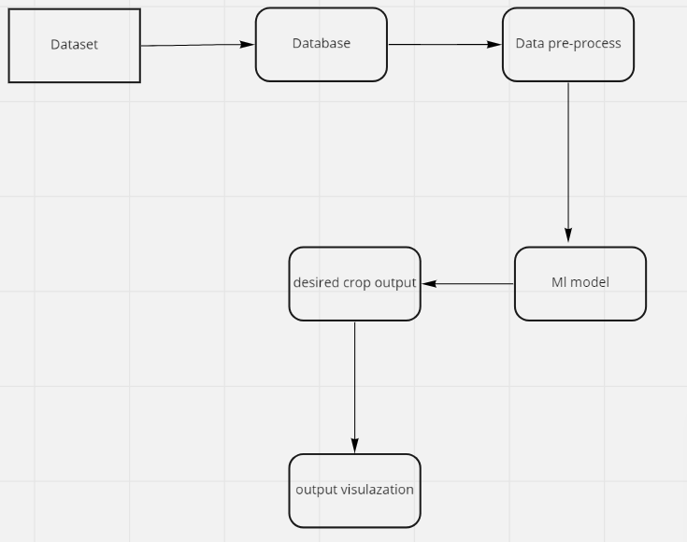

**6.1.2 Module Design**

**DFD LVL 0 :**

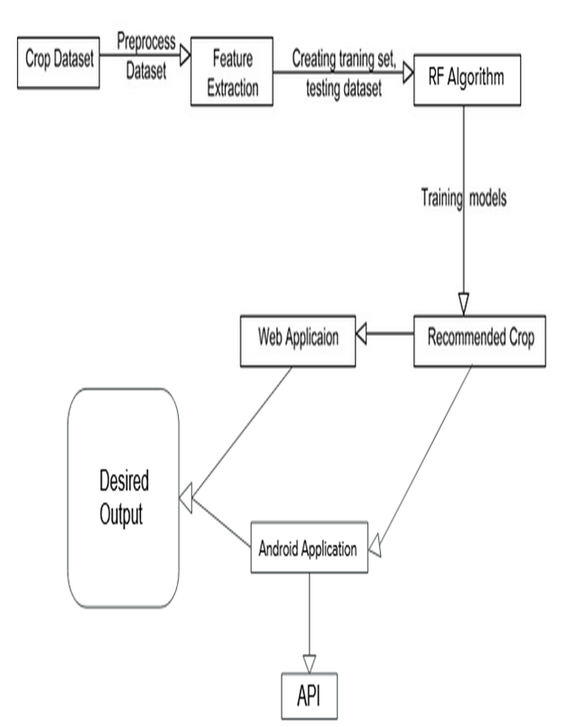

**DFD LVL 1 :**

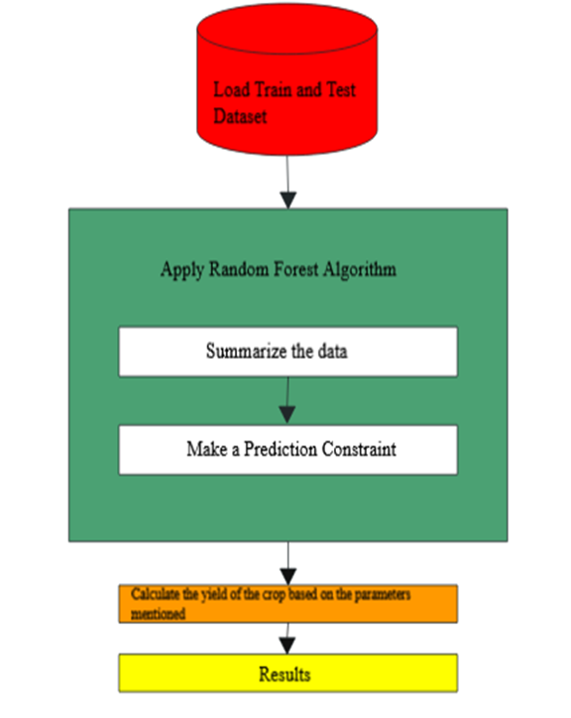

**DFD LVL 2 :**

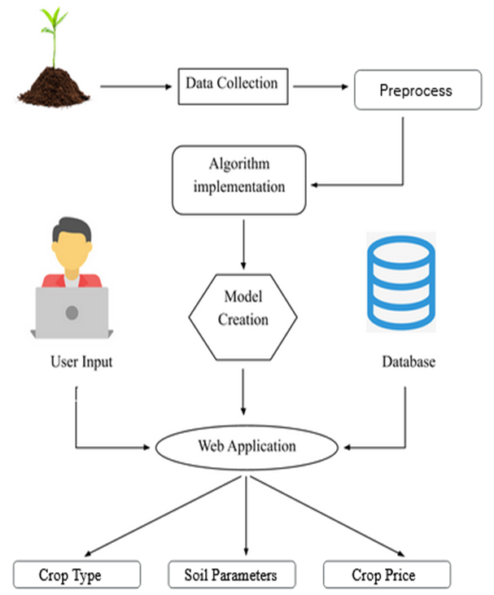

**6.2 Detailed Design**

**6.2.1 Sequence Diagram**

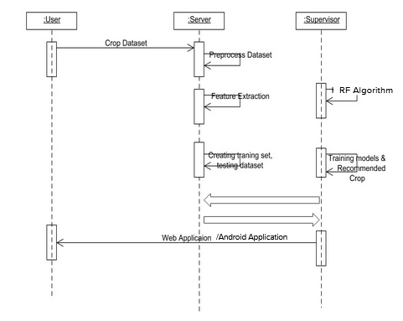

**6.2.2 Activity Diagram**

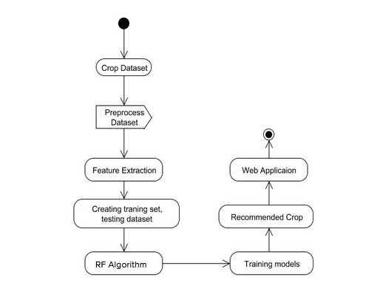

**6.2.3 Use Case Diagram**

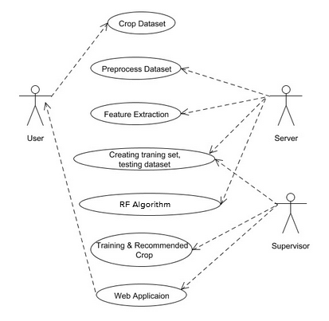

**CHAPTER-7**

**IMPLEMENTATION**

**Code Snippets:**

**i) Bucket policy for creating S3 Bucket:**

{

"Version": "2012-10-17",

"Statement": [

{

"Effect": "Allow",

"Principal": "*",

"Action": [

"s3:PutObject",

"s3:PutObjectAcl",

"s3:GetObject",

"s3:GetObjectAcl",

"s3:DeleteObject"

],

"Resource": [

"arn:aws:s3:::crop-dataset",

"arn:aws:s3:::crop-dataset/*"

]

}

]

}

**2.) Lambda Function:**

import json

import gspread

from oauth2client.service_account import ServiceAccountCredentials

import csv

import boto3

import pandas as pd

import xlsxwriter

import io

from io import BytesIO

from io import StringIO

s3 = boto3.resource('s3')

bucket = s3.Bucket('crop-dataset')

key='cropdata.csv'

def my_handler(event, context):

# use creds to create a client to interact with the Google Drive API

scope = ['https://spreadsheets.google.com/feeds', 'https://www.googleapis.com/auth/drive']

creds = ServiceAccountCredentials.from_json_keyfile_name('creds.json', scope)

client = gspread.authorize(creds)

temp_file = 'test.csv'

# Find a workbook by name and open the first sheet

# Make sure you use the right name here.

sheet = client.open('Datasetcapstone').sheet1

test = sheet.get_all_values()

df = pd.DataFrame(test)

**3.) ML Model**

from sklearn.svm import SVC

svc = SVC(kernel = 'linear', random_state = 42)

svc.fit(X_train, Y_train)

from sklearn.tree import DecisionTreeClassifier

dectree = DecisionTreeClassifier(criterion = 'entropy', random_state = 42)

dectree.fit(X_train, Y_train)

from sklearn.ensemble import RandomForestClassifier

ranfor = RandomForestClassifier(n_estimators = 100, criterion = 'entropy', max_features=3, oob_score=True, random_state = 42)

ranfor.fit(X_train, Y_train)

from sklearn.neighbors import KNeighborsClassifier as KNN

knn = KNN(n_neighbors = 3)

knn.fit(X_train, Y_train)

Y_pred_svc = svc.predict(X_test)

Y_pred_dectree = dectree.predict(X_test)

Y_pred_ranfor = ranfor.predict(X_test)

Y_pred_knn = knn.predict(X_test)

from sklearn.metrics import accuracy_score

accuracy_svc = accuracy_score(Y_test, Y_pred_svc)

accuracy_dectree = accuracy_score(Y_test, Y_pred_dectree)

accuracy_ranfor = accuracy_score(Y_test, Y_pred_ranfor)

accuracy_knn = accuracy_score(Y_test, Y_pred_knn)

a=accuracy_svc * 100

b=accuracy_dectree * 100

c=accuracy_ranfor * 100

d=accuracy_knn * 100

scores = [a,b,c,d]

algorithms = ["Support Vector Machine","Decision Tree","Random Forest","KNN"]

for i in range(len(algorithms)):

print("The accuracy score achieved using "+algorithms[i]+" is: "+str(scores[i])+" %")

sns.set(rc={'figure.figsize':(8,8)})

plt.xlabel("Algorithms")

plt.ylabel("Accuracy score")

sns.barplot(algorithms,scores)

with open('model.pkl', 'wb') as fid:

pickle.dump(ranfor,fid)

**4.) UI (Flask and HTML):**

from flask import Flask, render_template, request

import pickle

import numpy as np

mod = pickle.load(open('model.pkl', 'rb'))

app = Flask(__name__)

@app.route('/')

def index():

return render_template('index.html')

@app.route('/predict', methods=['POST'])

def predict_crop():

temp = float(request.form.get('temperature'))

hum = float(request.form.get('humidity'))

ph = float(request.form.get('ph'))

rain = float(request.form.get('rainfall'))

# prediction

result = mod.predict(np.array([temp, hum, ph, rain]).reshape(1, 4))

result1 = ",".join('As per the environmental conditions, the crop type is ' + result + ' and the price should be 37')

return render_template('index.html', result=result1)

if __name__ == '__main__':

app.run(host='0.0.0.0', port=8080)

**HTML:**

<!DOCTYPE html>

<html lang="en">

<head>

<meta charset="UTF-8">

<title>Crop price and label predictor</title>

</head>

<style>

body {

background-image: url('https://cdn.croptrust.org/wp/wp-content/uploads/2014/12/about-us.jpg');

background-repeat: no-repeat;

}

label {

display: inline-block;

<!-- width: 150px;-->

text-align: centre;

display: inline-block;

}

result {

display: inline-block;

width: 400px;

text-align: centre;

}

input[type=text]{

padding: 12px;

border: 1px solid #ccc;

border-radius: 4px;

box-sizing: border-box;

resize: vertical;

}

input[type=submit] {

background-color: #04AA6D;

color: white;

padding: 12px 20px;

border: none;

border-radius: 4px;

cursor: pointer;

}

.container {

border-radius: 5px;

padding: 20px;

}

</style>

<body>

<center>

<h1>Crop price and label predictor</h1>

<p>{{ result}}</p>

<form method="post" action="/predict">

<label>Temperature</label>

**CHAPTER-8**

**RESULTS (SNAPSHOTS)**

* **S3 Bucket:**
* **Docker image** 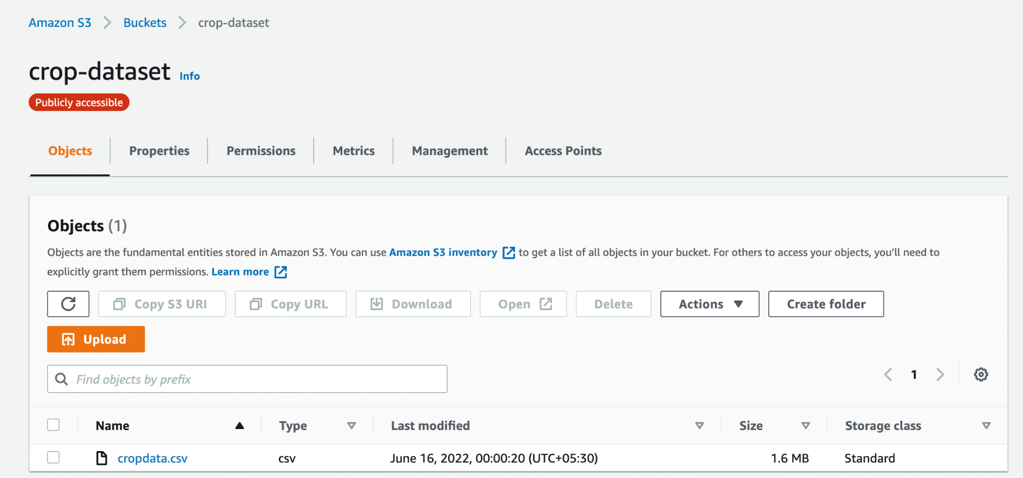

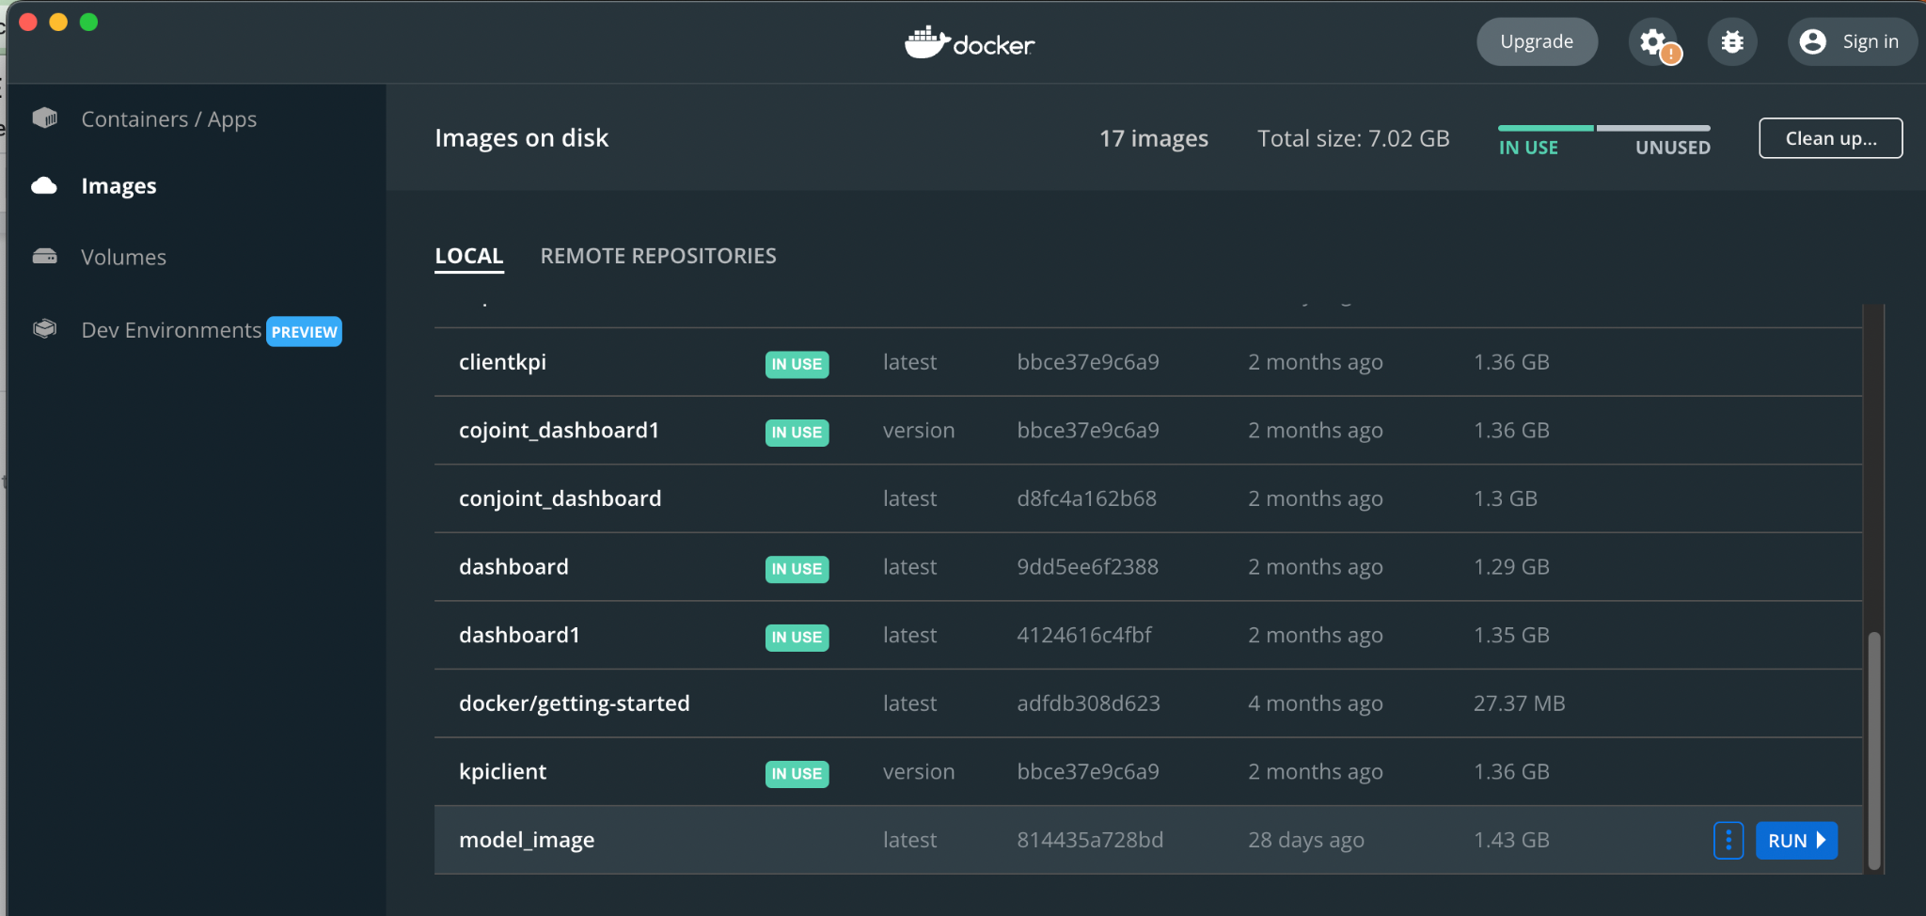

* **EC2 instance**

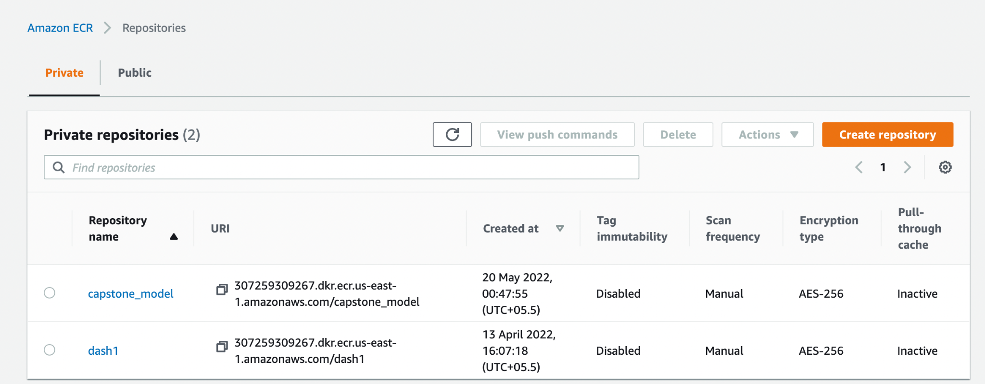

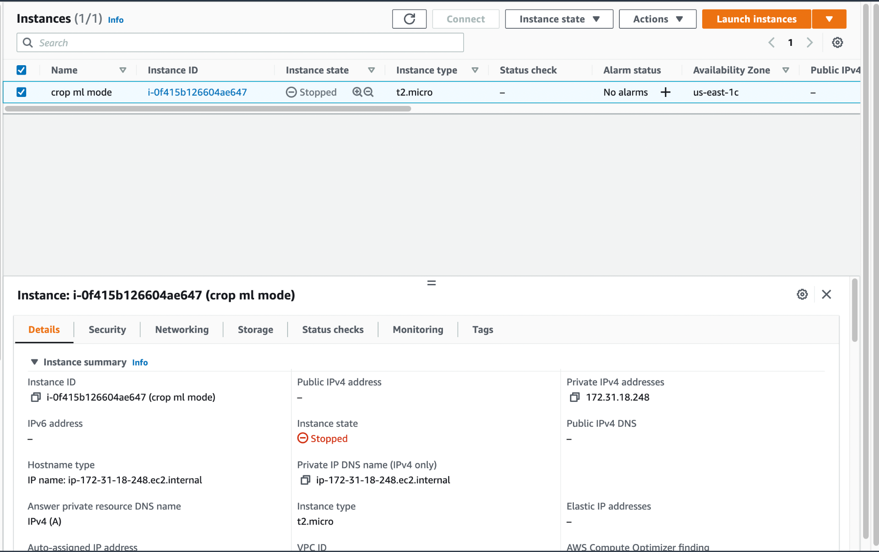

* **AWS Lambda function**

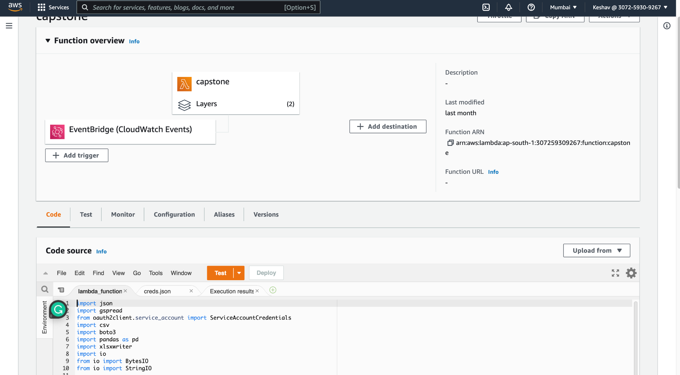

* **Results of deployed ML Model**

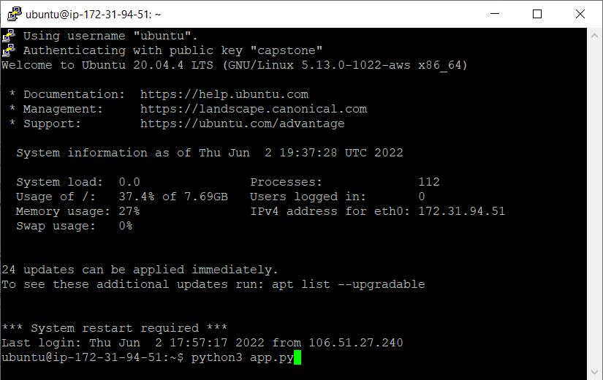

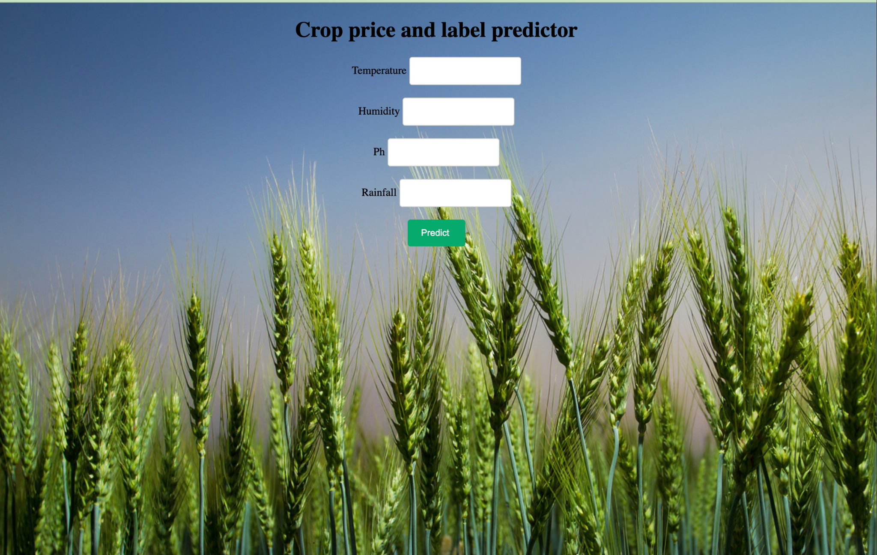

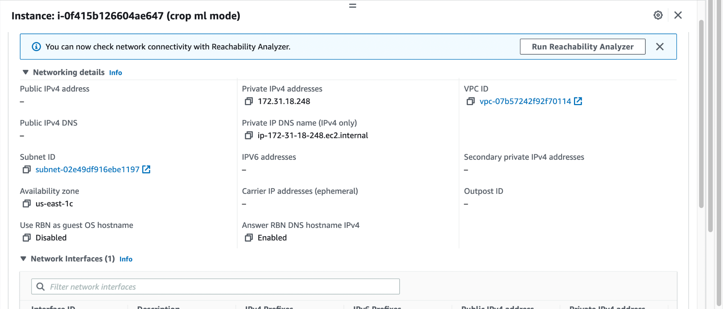

**CHAPTER-9**

**TESTING**

**Integration Testing:** Integration testing is a type of software testing in which the different parts of a software application are tested as a combined entity. There are many types of integration testing : top down approach, bottom up approach, sandwich testing and big bang testing. We have followed the bottom up approach for our work. Each part was tested manually first and then combined and tested.

|  |  |  |  |  |
| --- | --- | --- | --- | --- |
| **SLNo** | **Test Case**  **Description** | **Expected**  **Outcome** | **Actual**  **Outcome** | **Remarks** |
| 1 | Deploying Python application on localhost(using PyCharm) by giving sample inputs | The ML model gives correct output when run on localhost | The ML model gives correct output when run on localhost | Success |
| 2 | Checking if WinSCP has the required files | All files(Python application, requirements file, HTML page) required to run the python application on EC2 instance have been successfully uploaded | All files(Python application, requirements file, HTML page) required to run the python application on EC2 instance have been successfully uploaded | Success |
| 3 | Checking connection between local machine and EC2 | The EC2 instance can be successfully accessed from PuTTy, thus satisfying connection between local machine and EC2 instance | The EC2 instance can be successfully accessed from PuTTy, thus satisfying connection between local machine and EC2 instance | Success |

**Table 9.2**

* **System Testing:** In this type of testing the project as a whole is tested to check if it adheres to the specified functionality. In our work we have covered all workflows and ensured that it works.

|  |  |  |  |  |
| --- | --- | --- | --- | --- |
| **Sl**  **No** | **Test Case**  **Description** | **Expected**  **Outcome** | **Actual**  **Outcome** | **Remarks** |
| 1 | Deploying Python application on created EC2 instance using PuTTy and WinSCP | The ML model gives correct output(0/1) when run on EC2 instance(using a public DNS) | The ML model gives correct output(0/1) when run on EC2 instance(using a public DNS) | Success |

**Table 9.3**

**Chapter-10**

**APPLICATIONS**

* The application can be used by the farmers to know about the various parameters required to grow the right type of crop during the appropriate season.
* This project aims to reduce suicide rates amoung farmers due to lack of income.
* It is user-friendly and easy to use.
* It’s cost effective, and time saving.
* Crop yield prediction is an essential task for the decision-makers at national and regional levels (e.g., the EU level) for rapid decision-making.
* An accurate crop yield prediction model can help farmers to decide on what to grow and when to grow.
* ML techniques used in this project will result in cost-effective solutions in the agricultural sector.

**CONCLUSION AND FUTURE ENHANCEMENTS**

* The system proposes to help farmers determine which crop to grow by performing analysis on its different parameters and to predict crops based on the results obtained.
* Upon classifying and analyzing the data, new insights can be obtained from the said data. Hence, various data analytical procedures and algorithms were studied in order to create analytical models best suited for the respective prediction..
* Some features that can further enhance the current model:
* Accuracy of the Machine Learning model can be increased by increasing the size of the dataset.
* Prediction for crops other than seasonal can be done to provide a much more generic solution.
* Data from other countries can be accumulated and fed to the current model to improve efficiency and accuracy.
* The form for collecting user input can be made more user friendly, captivating and interactive, while adding more functionalities, so that it can be a one-stop solution for several other queries.
* Security aspects of the cloud can be increased by creating a login based system, in order to provide restricted access to the results of analysis and visualization.
* A static URL can be created for the output of the EC2 instance by using AWS VCS, rather than the EC2’s Public DNS, which changes each time the instance is restarted.
* A step function can be implemented to automate the entire procedure even further to reduce the need of human intervention.
* Both aspects of the model can be integrated together into a single website that performs all the analysis, computations, and other processes for the prediction.

**BIBLIOGRAPHY**

1. Prabodh Sakhardande, Sumeet Hanagal, Savita Kulkarni,”Design of disaster management system using IoT based interconnected network with smart city monitoring”, IEEE Paper 2016.
2. [Jeanette Rohr](https://news.sap.com/author/jeanetterohr),”Blockchain for Disaster Relief: Creating Trust Where It Matters Most”, SAP News Center, Nov 2017.
3. Craig Guillot, “How Blockchain Could Speed Hurricane Disaster Relief”, IEEE Paper, July 2018.